USF Public Art Program

TOMÁS SARACENO
CAELUM DUST, 2016
http://www.usfcam.usf.edu/PA/Pages/pa_saraceno.html
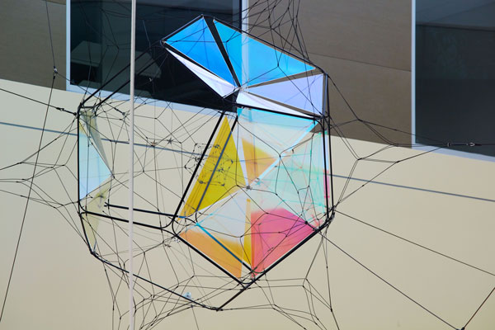
Detail of one of the structures.
LOCATION:
University of South Florida, Tampa
Interdisciplinary Sciences Building
PROJECT DESCRIPTION:
Caelum Dust (2016) is comprised of three network modules, of varying scale, that span the atrium creating a complex and dynamic dialogue within the architectural space. Forming an artistic pattern of interconnectedness and a bridge between disciplines, the sculptural modules may resemble nucleuses, neuron networks, spider web formations, nebulous structures or asterisms set in the firmament. Saraceno’s on-going research of spiders and their webs serve as a structural metaphor to describe how matter is dispersed in the Universe, forming interwoven filaments of galaxies, stars and planets, or the cosmic web. The installation casts kaleidoscopic reflections through iridescent dichroic panels that change color as the viewer moves through the space. The evolving transformation of perceiving the artwork makes the aesthetic experience a synesthetic moment, during which one discovers the gamut and boundaries of our sensoria and perception.
Trained as both an architect and a visual artist, Saraceno works in the crossroad of art, physics, biology, astronomy and engineering, and explores ideals of human interconnectivity and new, sustainable ways to inhabit and sense the environment. In 2015, he achieved the world record for the first and longest certified fully-solar manned flight. During the past decade, he has taken up collaborations with renowned scientific institutions, including the Massachusetts Institute of Technology, Max Planck Institute, the Nanyang Technological University of Singapore, and the Natural History Museum London.
Saraceno was born in Argentina and currently lives and works in Berlin and beyond the planet Earth. He has held residencies at Centre National d’Études Spatiales (2014–2015), MIT Center for Art, Science & Technology (2012–ongoing) and Atelier Calder (2010), among others. In 2009, Saraceno attended the International Space Studies Program at NASA Ames. The same year he presented a major installation at the 53rd Venice Biennale, and was later awarded the prestigious Calder Prize. His work has been widely exhibited internationally in both solo and group exhibitions. Saraceno’s work is included in the collections of The Museum of Modern Art, New York; SFMOMA, San Francisco; Walker Art Center, Minneapolis; Nationalgalerie, Staatliche Museen zu Berlin, Berlin; among others.
Check out a time-lapse of the installation on YouTube below. https://youtu.be/5KeQK5wLX6s
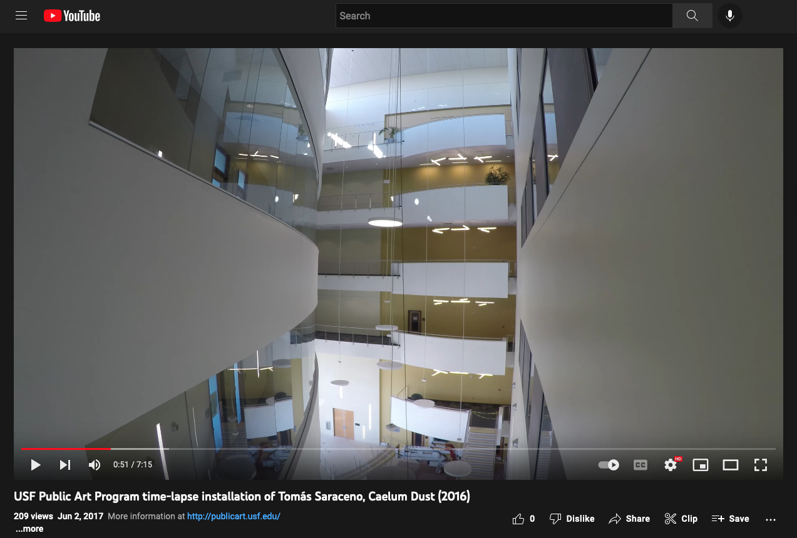
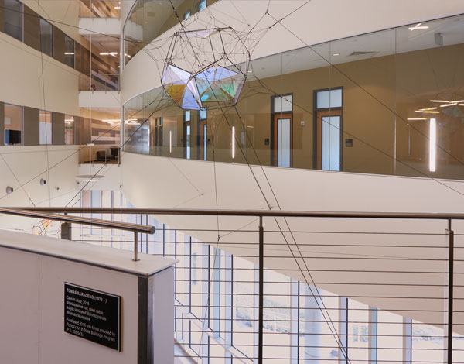
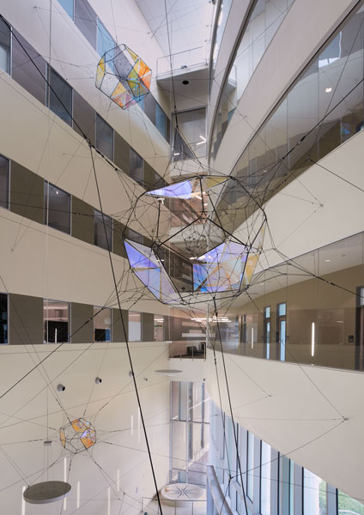
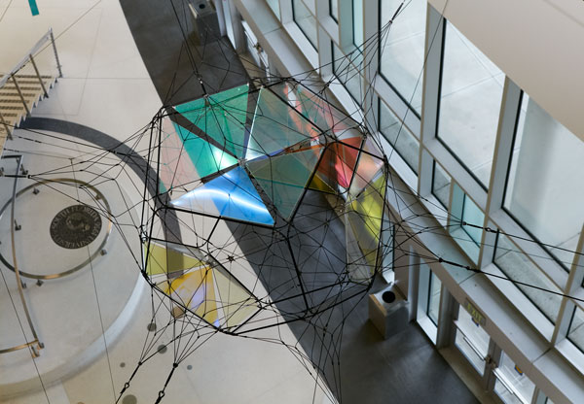
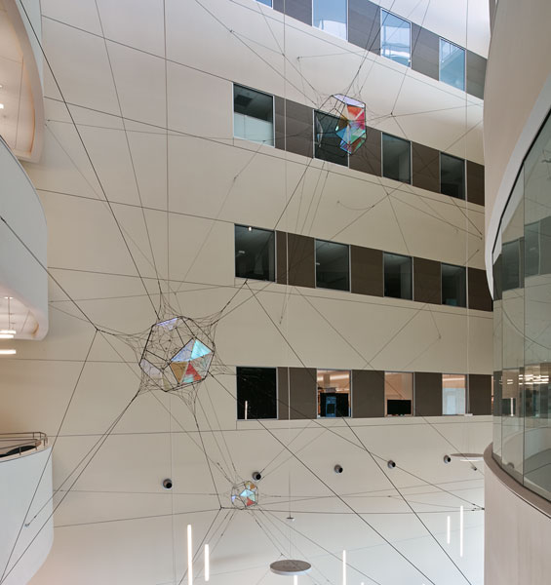
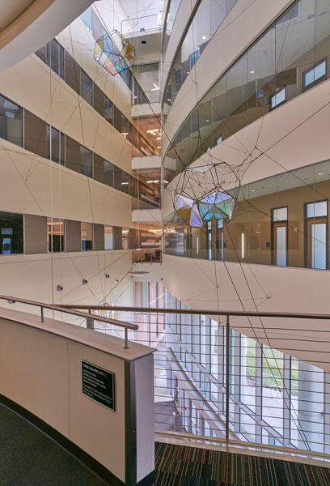
Caelum Dust made possible by Florida's Art in State Buildings Program

